Name: |  | ___________________________________________________ |  |  |  | Date: ___________
 |  | Subject :Year 11 Applications  Test 6, 2015  Topics – Normal distribution and trigonometry |  |  |  | 57  = %
Total Time: |  | 60 minutes
Total Reading: |  | 5 minutes
Total Working: |  | 65 minutes
Weighting: |  | 10% of the year.
Equipment: |  | Curriculum Council Formula Sheet; ½ page notes (A4 one side), CAS calculator; Scientific Calculator
1. | [ 4 marks: ]  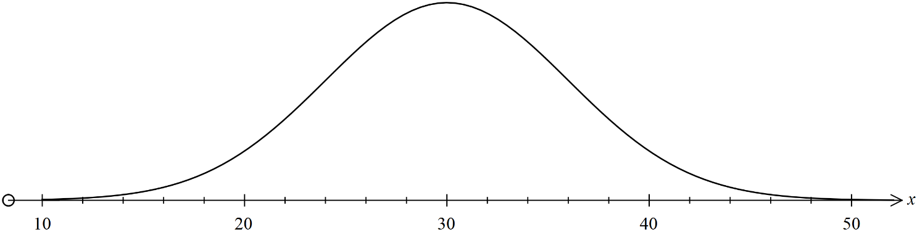  If X ~(30, 5²) determine the probability using the 68%, 95% and 99.7% rule:
- P (25 < X < 35 )

- P ( 20 < X < 40)

- P (30 < X < 40)

- P (X ≤ 35)

2. | [ 6 marks]  Find the value of the unknown for each of the following triangles to 2 decimal places:
 | 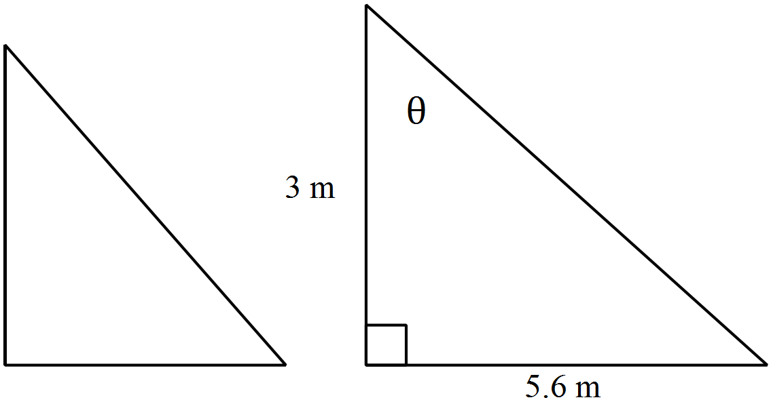 |  | 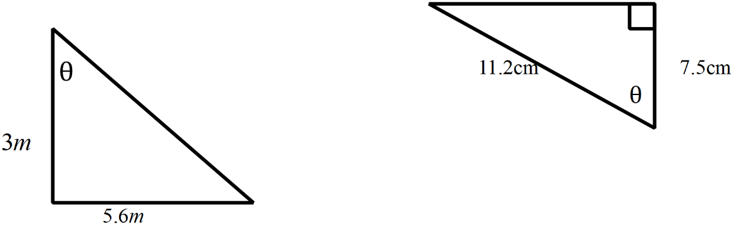 |  | 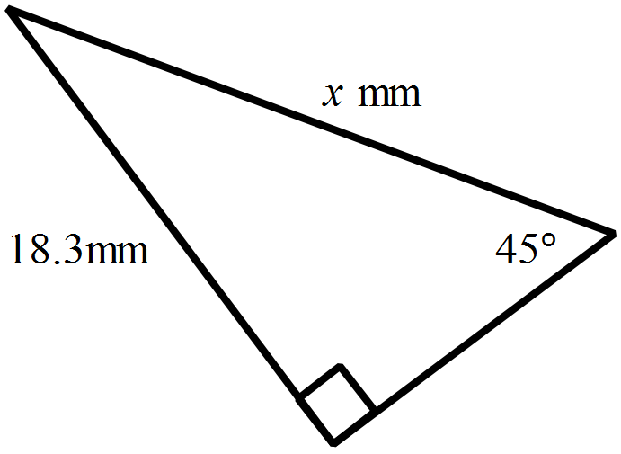

3. [ 6 marks]
State the true bearing and the compass bearing for each of the following:
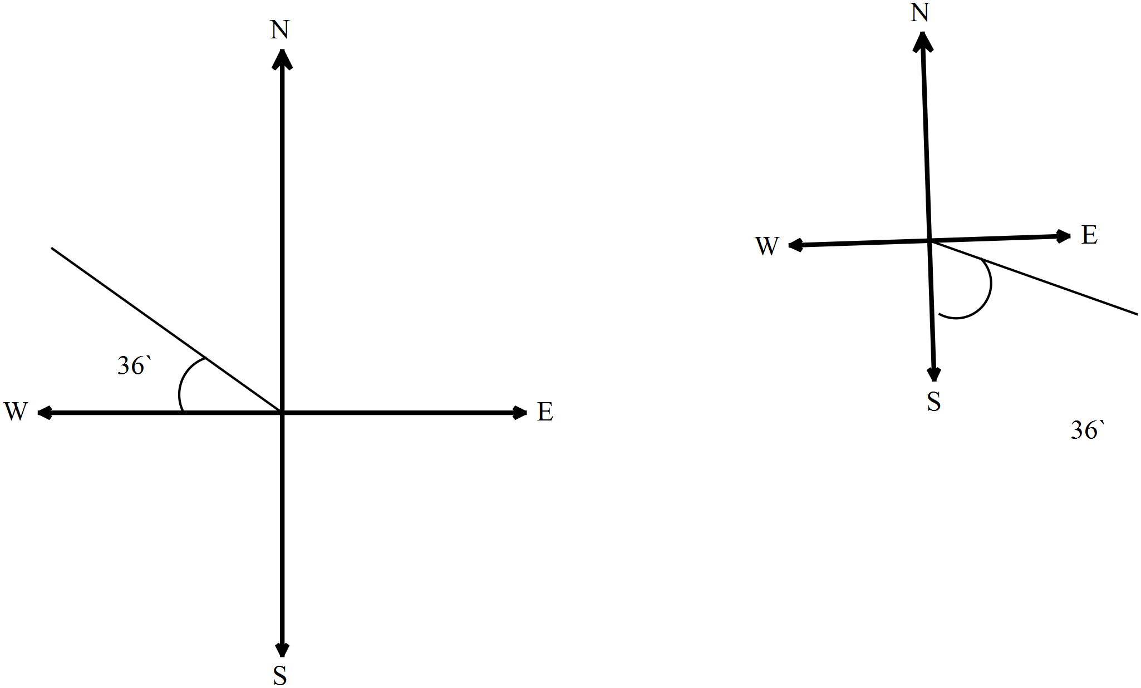  True bearing:  Compass bearing: | 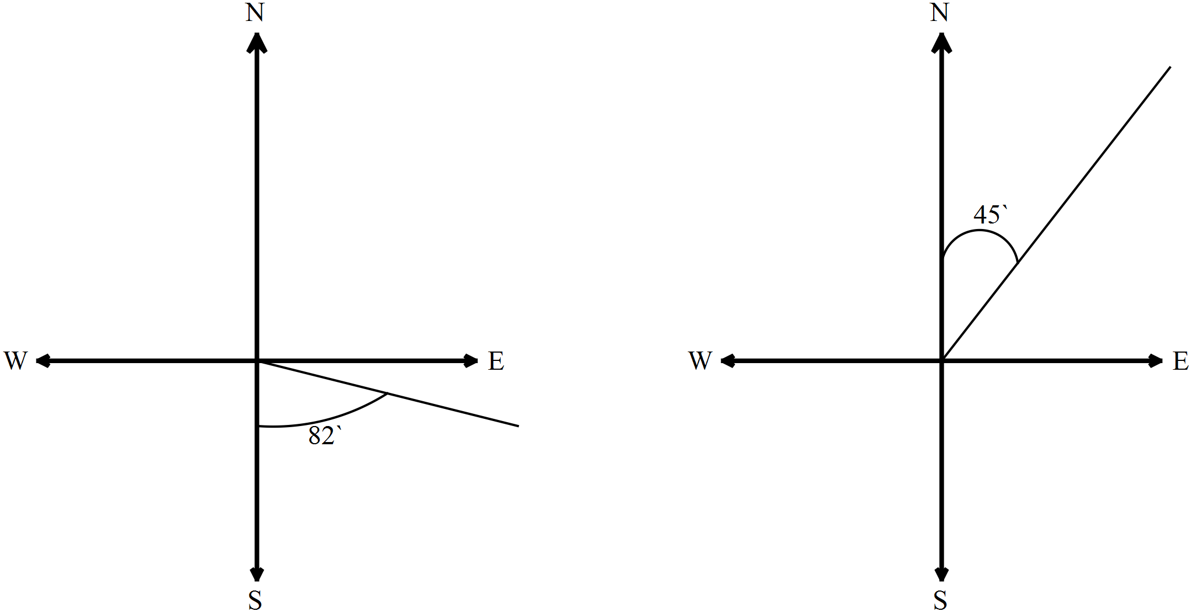  True bearing:  Compass bearing: |   True bearing:  Compass bearing:
4. [ 3 marks]
3520 year 11 applications students at Springfield Elementary sat their final examinations. The scores obtained were normally distributed, with a mean of 57 and a standard deviation of 9.5
  - Scholarships were awarded to students who gained a mark of 85 or above. How many students gained scholarships?
  - A mark of less than 45 was considered a fail. How many students failed?
5. [ 2 marks]
A lifeguard is sitting at the top of a lookout and spots a person in the water at an angle of depression of 11.5°. If the lookout is 7m high, calculate the distance (to the nearest meter) from the base of the lookout to the person (HINT: Draw a diagram)
- [ 3 marks]
Two buildings are directly opposite each other, on either side of a street. One building is 330m tall and the other is 152m tall. The angle of depression from the top of the taller building to the top of the smaller building is 46°. How far apart from each other are the buildings (Sketch a diagram of the scenario).
7. [ 2 marks]
A non right angled triangle has the following dimensions a= 52cm b= 67cm and C= 12° :
What is the area of triangle ABC to the nearest cm² ?
8. [ 2 marks:]
A kite is flown on a string that is 52m long and is anchored to the ground. Find the angle (to 2 d.p) that the string makes with the ground when the height of the kite is 28m above the ground.
9. [ 4 marks ]
A 1.65m person is bird watching from a lookout that is 55m tall. He spots a falcon in the sky at an angle of elevation of 34° from the top of his head. If the bird is horizontally 1.15m, from the lookout, calculate how high the bird is from the ground (2 d.p).



55 m
1.63 m
34°
1.15 m
10. [ 3 marks ]
A ship leaves port and sails on a bearing of S 25° E for 300km, then travels 120km due north and anchors. How far is the boat from the port whilst he is anchored?
11. [ 5 marks]
A tightrope walker in a circus is walking from one side of the big top to the other. When he starts, he notices a clown on the ground at an angle of depression of 15°. He then walks 10m along the tightrope and notices that the clown is now at an angle of depression of 29°.
Find the height (h) in metres of the tightrope from the ground level (to 2 d.p).
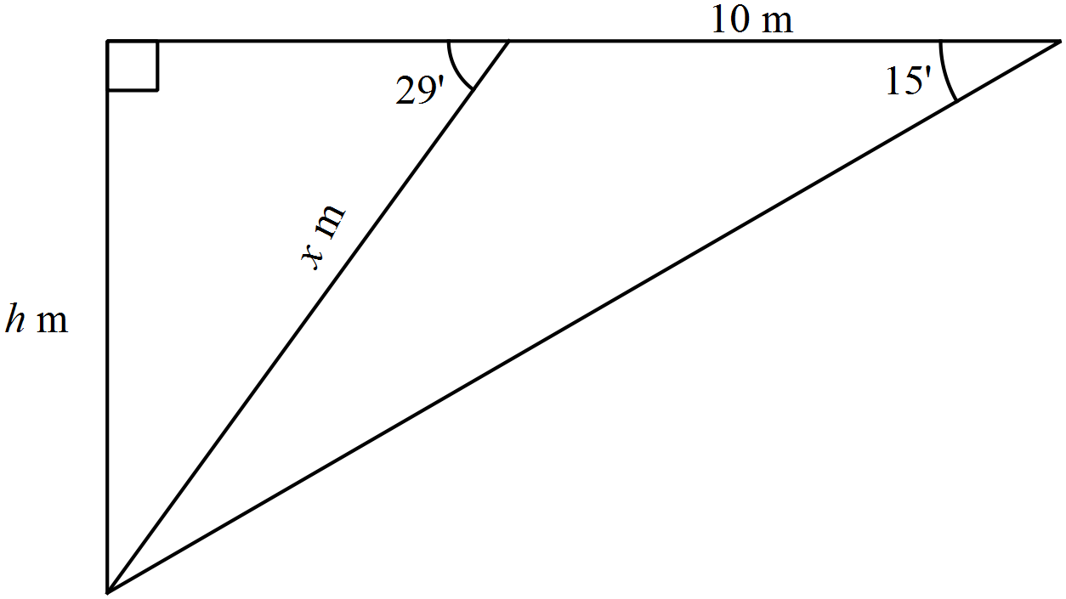
12. [ 5 marks: 1, 1]
A non right angled triangle has the following dimensions a= 52cm b= 67cm and c = 37 cm find:
- The value of the smallest angle Ө in the triangle ABC
(Hint: Sketch a diagram)
- What is the area of triangle ABC to the nearest cm² ?
13. [4 marks]
Justin is building a triangular play pen for his miniature pigs to play in, and he wants to cover it in artificial grass.
- Find the area of grass that is needed to cover the play pen (to the nearest m²)
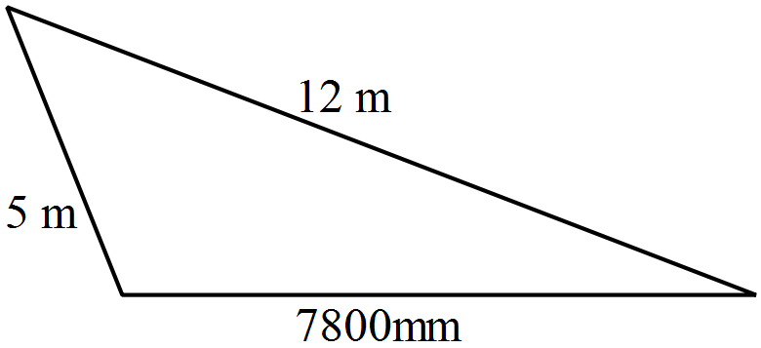

- If the artificial grass costs $15.50/m² what is the cost of covering the play pen in artificial grass?
~ END OF TEST SECTION 1 ~

